Practical 1 :
Initiate the semester-log studentHub portal by identifying the problem scope , user roles , key modules , navigation flow ,and minimum 10 pages.
Wireframe :
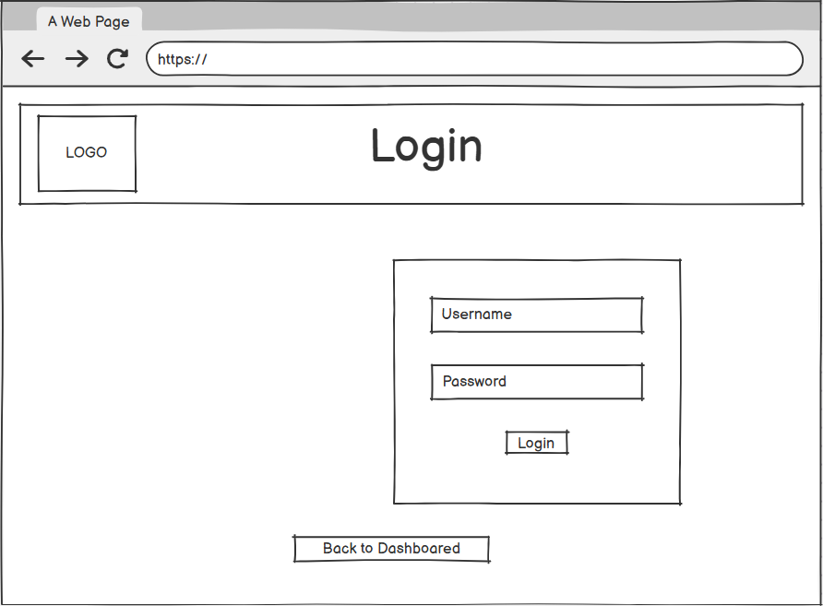
Figure 1: Login Page

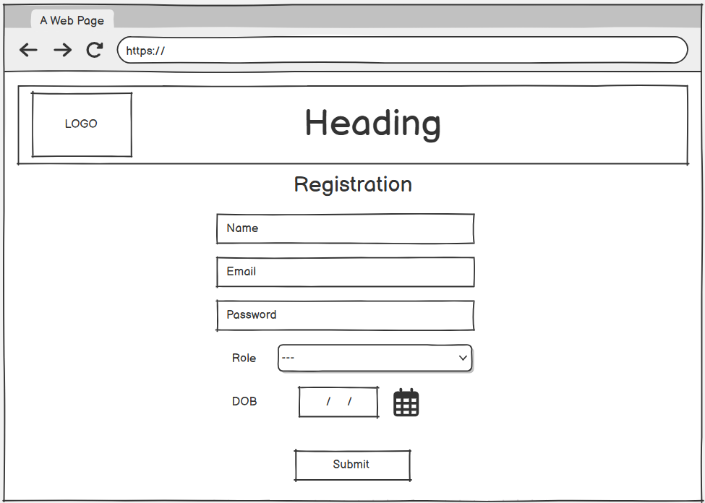
Figure 2 :Registration
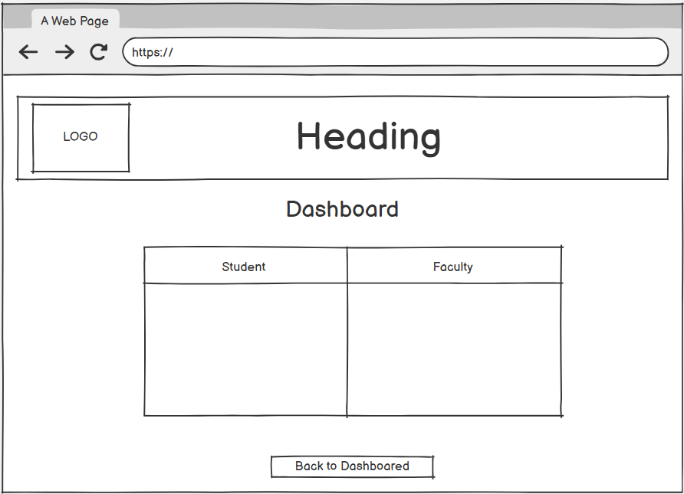
Figure 3 : Dashboard

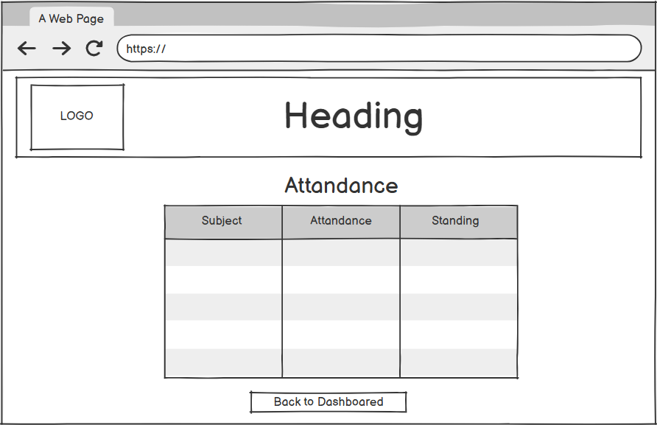
Figure 4 : Attendance

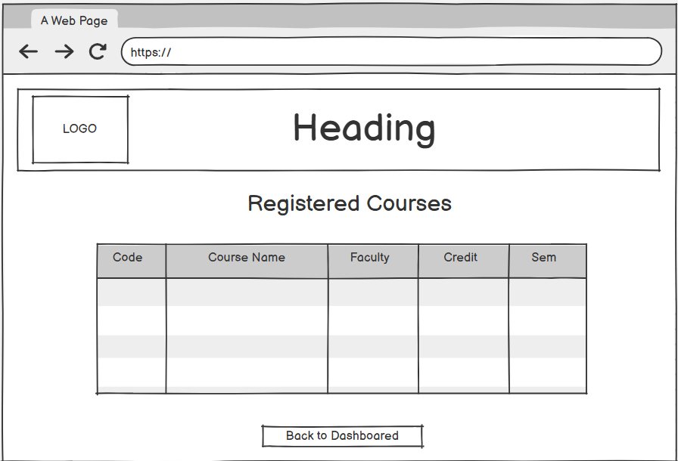
Figure 5 : Registered Courses

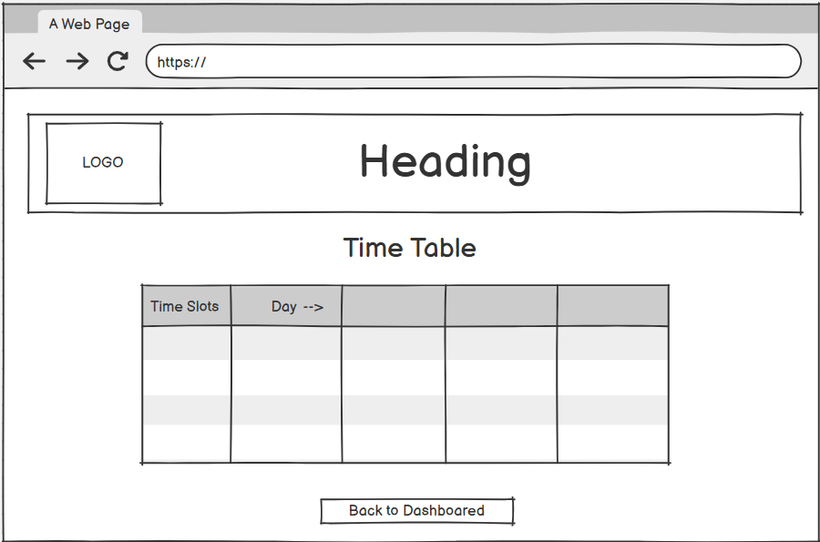
Figure 6 : Time table

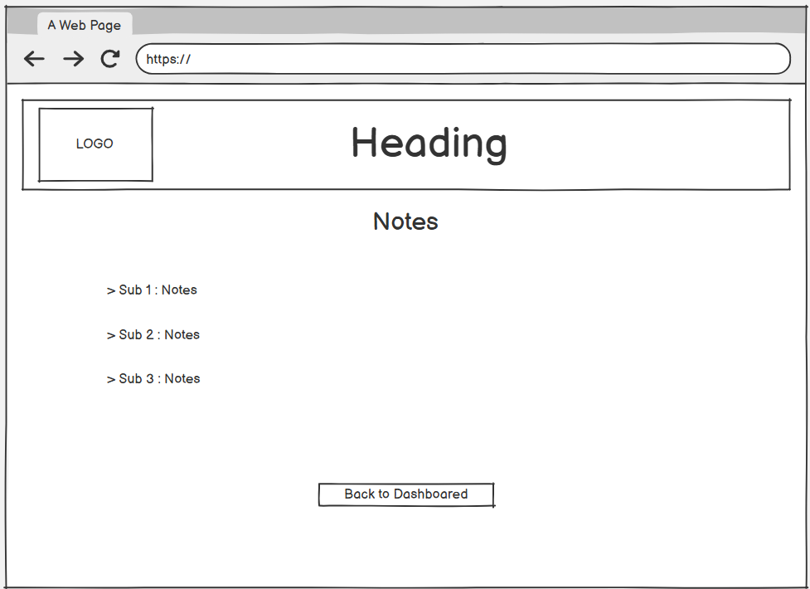
Figure 7 : Notes

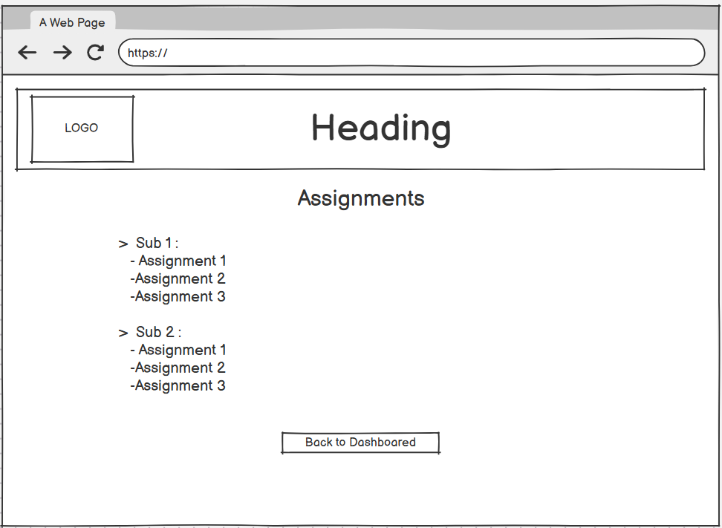
Figure 8 : Assignment

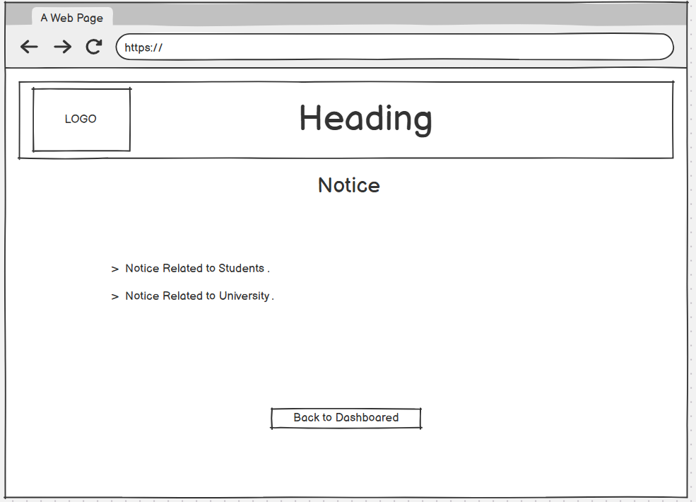
Figure 9 : Notice

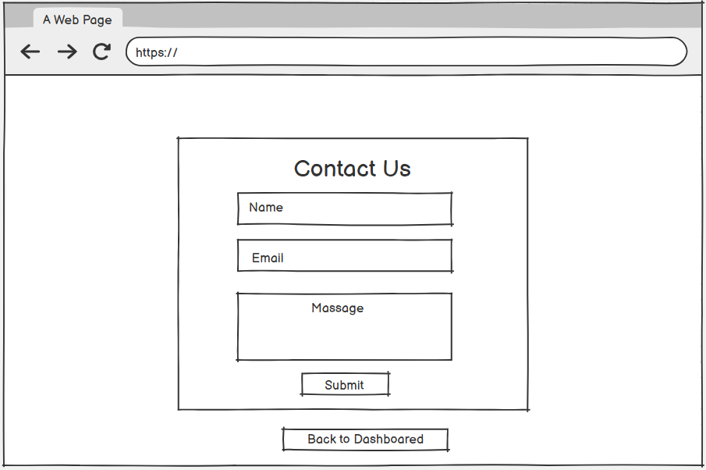
Figure 10 : Contact us

Sitemap :

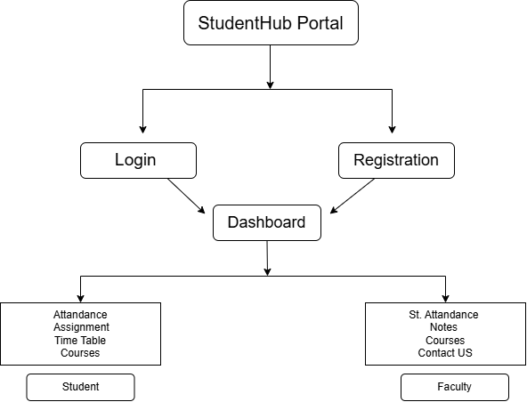
Figure 11 :SITEMEP

